# Configuring Auto-Assign Inspections

## Learning Objectives

After you complete this course guide, you will know how to:

* Define auto-assign inspections from both an end-user and an administrator perspective (see page 1)
* Set the FIDs that enable auto-assign inspections (see page 2)
* Configure inspection disciplines (see page 5)
* Configure inspection districts (see page 6)
* Configure inspection time blocks (see page 10)
* Set inspection types for auto-assignment (see page 14)
* Configure inspection calendars (see page 19)
* Configure inspector profiles (see page 32)

To get the most from your learning experience, we recommend that you complete the exercises and review the related information listed at the end of this course guide.

## Overview

When Accela Automation is configured for auto-assign inspections, the software automatically balances the inspectors’ workload and assigns an inspector by their discipline, district, and availability. This saves the user’s time and greatly simplifies the scheduling process — they only need to click the Auto Assign button to schedule an inspector.

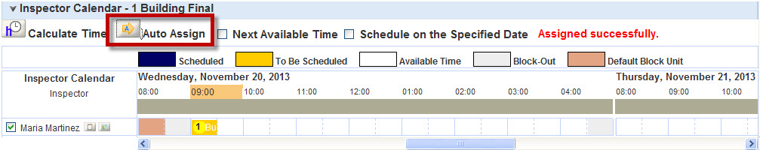

To configure auto-assign inspections, you need to complete the following steps in this order:

1. Set the function identifiers (FIDs).
2. Add the inspection disciplines to your system.
3. Add the inspection districts to your system.
4. Specify the time blocks for the inspections.
5. Set the inspection types for auto-assignment.
6. Configure the inspection calendar for auto-assignment.
7. Configure the inspector profiles.

## Setting the Function Identifiers (FIDs)

To successfully configure auto-assign inspections, you need to enable the following FIDs:

* 8287 Auto-Assign Inspection. This FID allows users to schedule auto-assign inspections. 8272 must be enabled for each user group that schedules inspections.

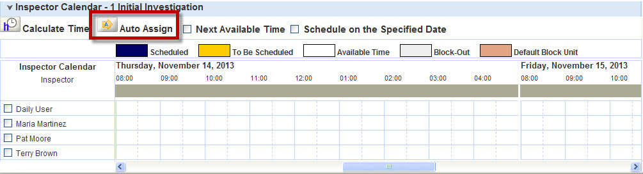

* 0218 Admin Auto-Assign Inspection. This FID enables the inspection discipline setting in the inspection types, so that administrators can assign disciplines to an inspection type. You need to enable 0218 for each user group that configures inspections.

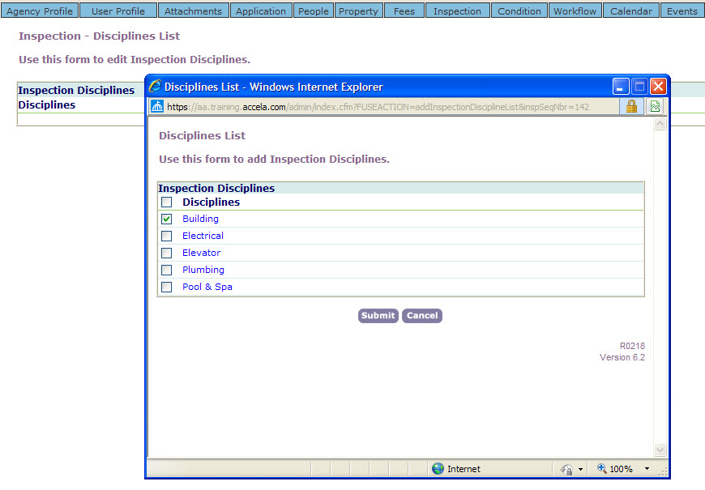

* 0257 Admin Inspection Calendar. This FID enables the inspection calendar in the Calendar administration portlet. 0257 must be enabled for each user group that configures and manages the inspection calendar.

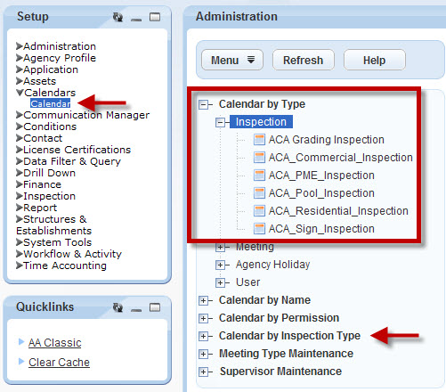

* 8281 Inspector Districting. This FID enables the District tab in the Address and Parcel portlets. You need to enable 8281 for each user group that assigns districts to reference or transactional addresses and parcels.

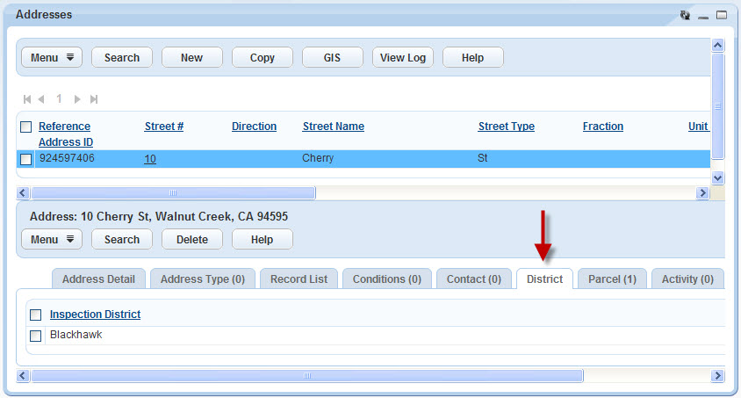

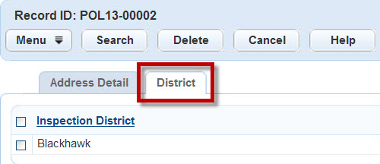

* 0207 Admin Inspector Districts. This FID enables the User Information link in the user profile, so that administrators can assign districts and disciplines to inspectors.

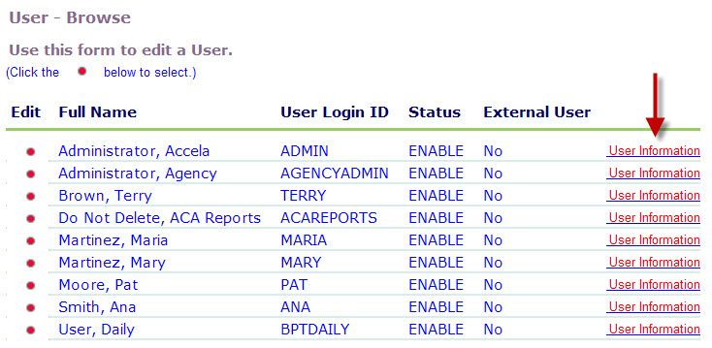

Accela Automation can also obtain scheduling information from the User and Agency Holiday calendars to automatically schedule inspectors. If your agency uses these calendars, you will also need to enable the following FIDs:

* 0336 User Calendar. This FID enables the User calendar in the Calendar administration portlet.0336 must be enabled for each user group that configures and manages the User calendar.

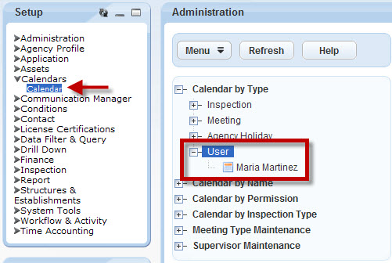

* 0337 Agency Holiday Calendar. This FID enables the Agency Holiday calendar in the Calendar administration portlet. 0337 must be enabled for each user group that configures and manages the Agency Holiday calendar.

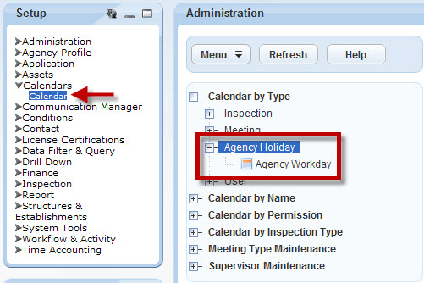

notes_final25For detailed instructions on how to set these FIDs, see [Setting Function Identifiers](http://community.accela.com/accela_automation/m/aatraining/8135/download.aspx).

## Configuring Inspection Disciplines

When a user auto-assigns an inspection, Accela Automation first looks for the inspectors that have the appropriate inspection discipline. For the auto-assign process to work properly, you first need to add the inspection disciplines to the shared drop-down list, USER\_DISCIPLINES, before you can successfully assign inspection disciplines to the inspectors (see page 19) and to the inspection types (see page 14).

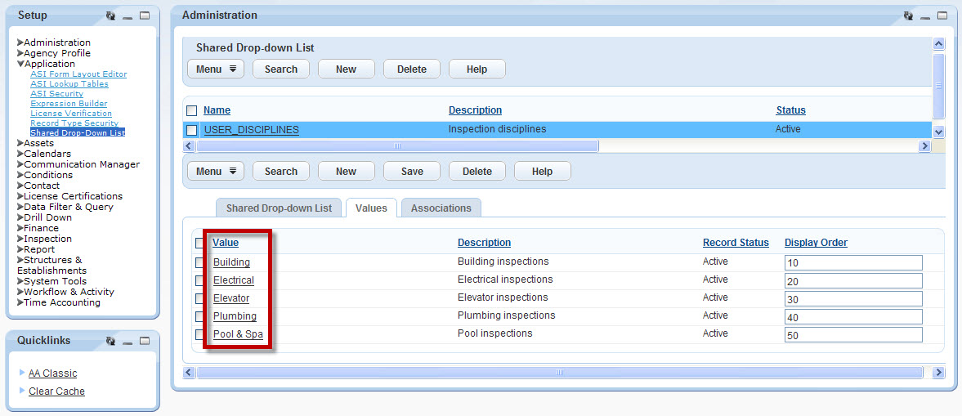

notes_final25For instructions on how to configure USER\_DISCIPLINES, see [Configuring Shared Drop-Down Lists](http://community.accela.com/accela_automation/m/aatraining/8144/download.aspx).

## Configuring the Inspection Districts

When a user auto-assigns an inspection, Accela Automation matches the inspectors’ district with the address or parcel district.

For the auto-assign process to work properly, you need to add the inspection districts to Accela Automation, and then associate the districts with either the addresses or the parcels.

To avoid manually adding the inspection districts to all of the addresses or parcels, you can include the inspection districts as part of the APO data conversion.

### Adding Inspection Districts to Accela Automation

To add the inspection districts to your system, you need to configure the shared drop-down list, USER DISTRICTS:

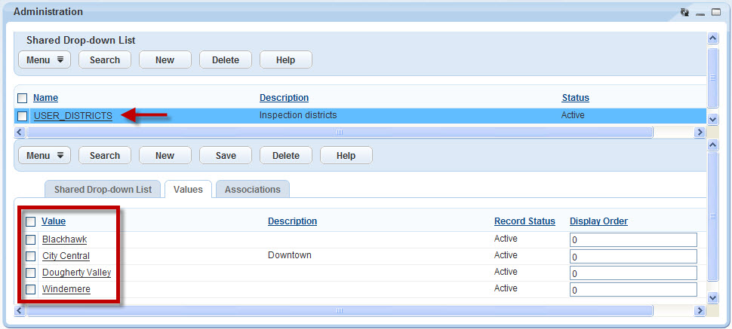

notes_final25For detailed instructions, see [Configuring Shared Drop-Down Lists](http://community.accela.com/accela_automation/m/aatraining/8144/download.aspx) and the [Accela Automation 7.3 Configuration Reference](http://community.accela.com/accela_automation/m/accela_automation_-_documentation_73/7995/download.aspx).

### Associating Districts with Addresses

To associate an inspection district with a reference address:

1. Navigate to the Property console page.

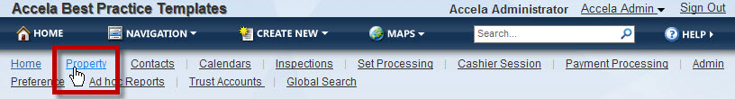

1. From the Address portlet, find an address by typing your search criteria into the form and clicking Submit.

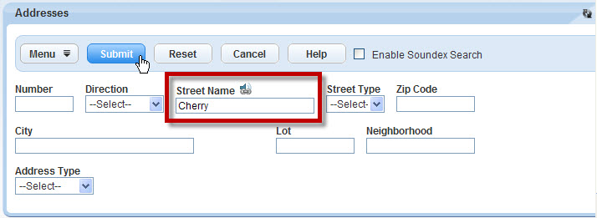

1. Select the address.

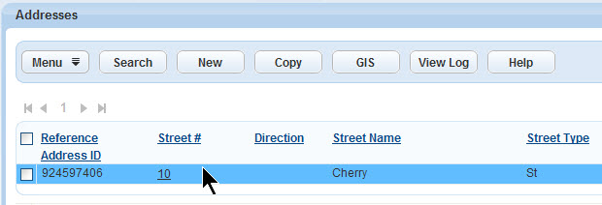

1. From the Address detail portlet, click District.

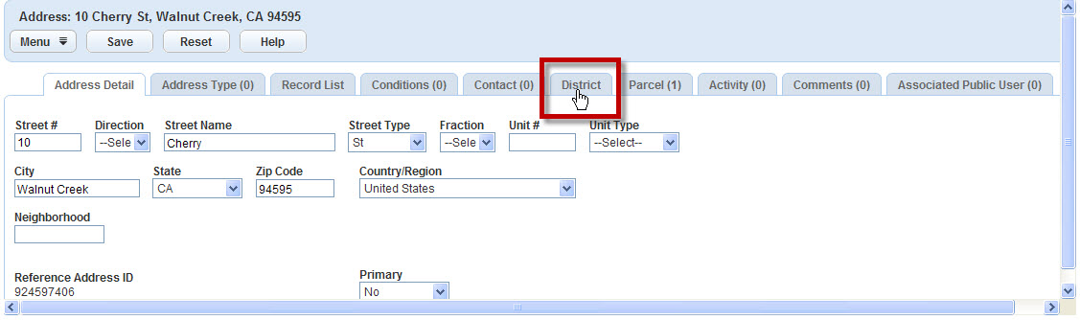

1. Click Search.

Image of the mouse clicking the search button.

1. To select the district, mark the check box, and then click Submit.

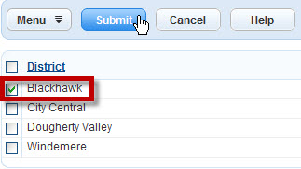

You see a confirmation message:

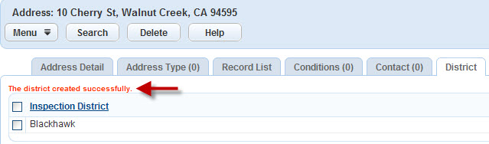

1. Repeat Steps 2 through 6 until you associate all of the reference addresses with a district.

### Associating Districts with Parcels

To associate an inspection district with a reference parcel:

1. Navigate to the Property console page.



1. From the Parcels portlet, find a parcel by typing your search criteria into the form, and then clicking Submit.

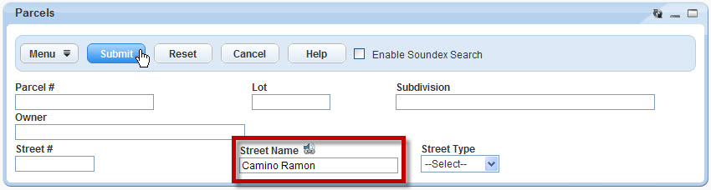

1. Select the parcel.

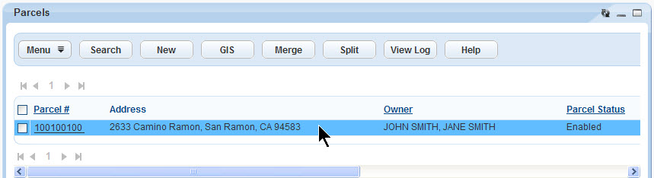

1. From the Parcel Detail portlet, click District.

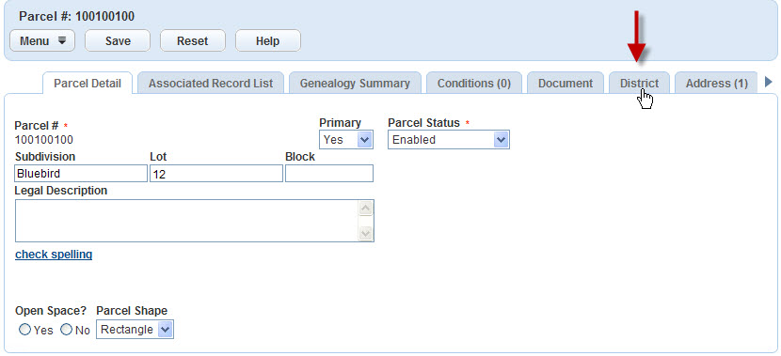

1. Click Search.

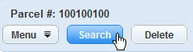

1. To select the district, mark the check box, and then click Submit.

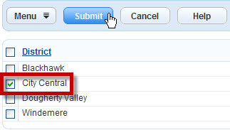

You see a confirmation message:

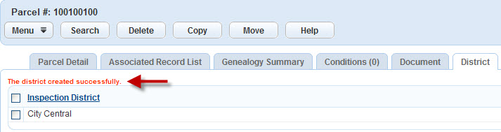

1. Repeat Steps 2 through 6 until you associate all of the reference parcels with a district.

## Configuring Time Blocks for Inspections

For Accela Automation to auto-assign inspections properly, you need to set a default block of time for the inspection units.

The default time block is set in the inspection calendar, and is equivalent to 1 inspection unit. For example, in the following calendar for residential inspections, 1 inspection unit is equal to 30 minutes:

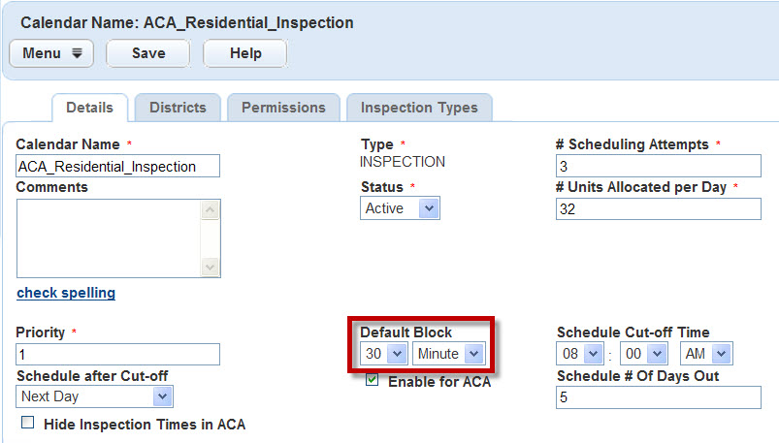

The inspection units tell your system how much time to allocate to an inspection, how many inspections an individual inspector can complete in a day, and how many inspections an agency can schedule in a day.

The inspection type defines the time allocated to complete the inspection:

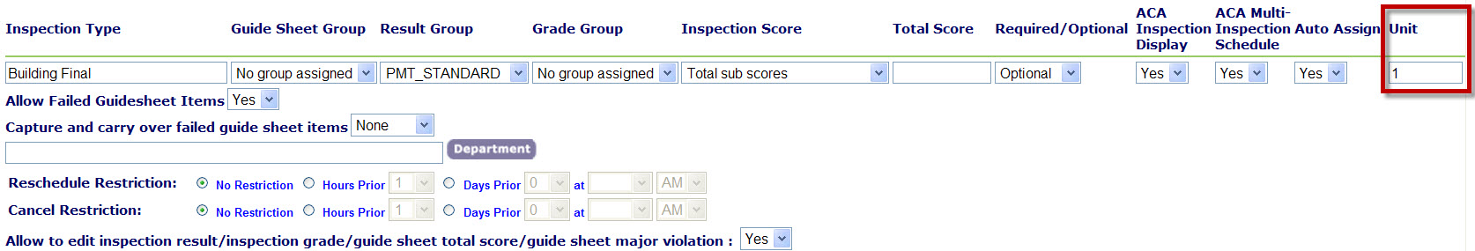

The inspector profile defines how many inspections the inspector can complete each day:

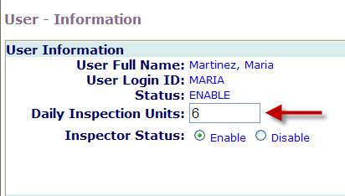

The inspection calendar defines how many inspections the agency can schedule in one day:

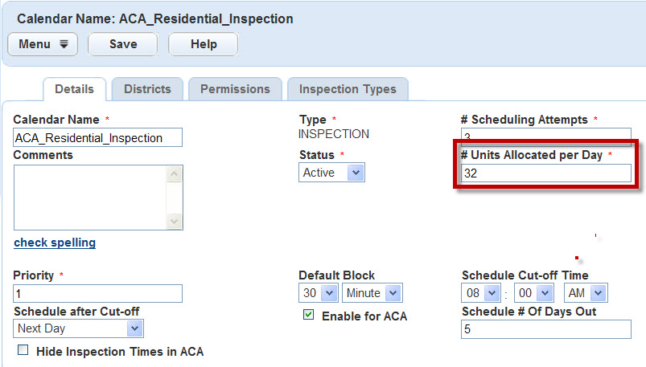

To set the default time block, you need to configure the following Standard Choices:

* CALENDAR\_BLOCK\_UNIT. This Standard Choice defines the units for the default time block in the inspection calendar.

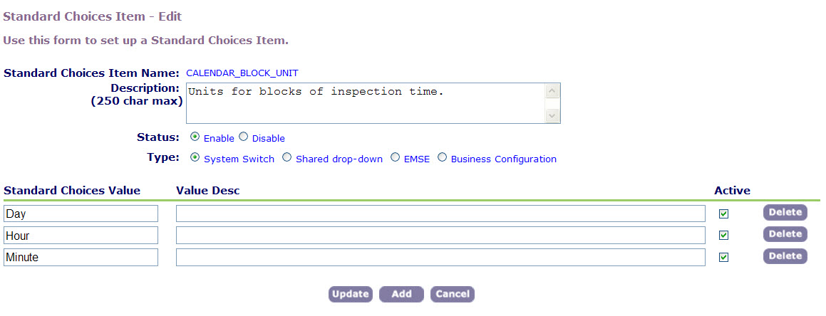

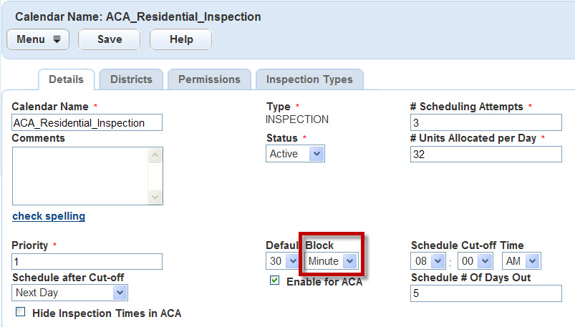

* CALENDAR\_BLOCK\_SIZE. This Standard Choice defines the quantity for the default time block in the inspection calendar.

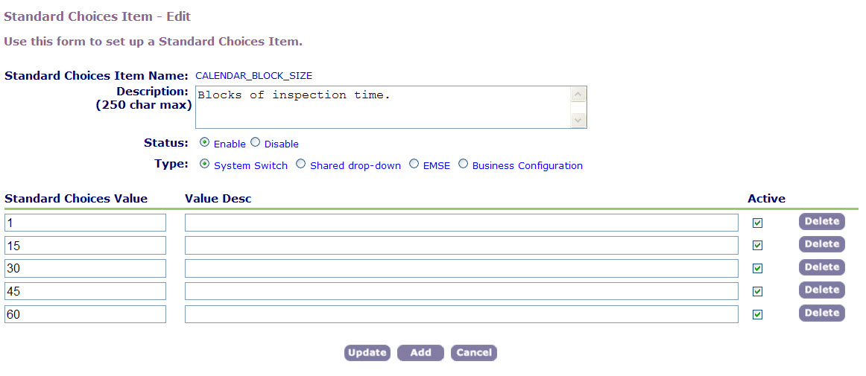

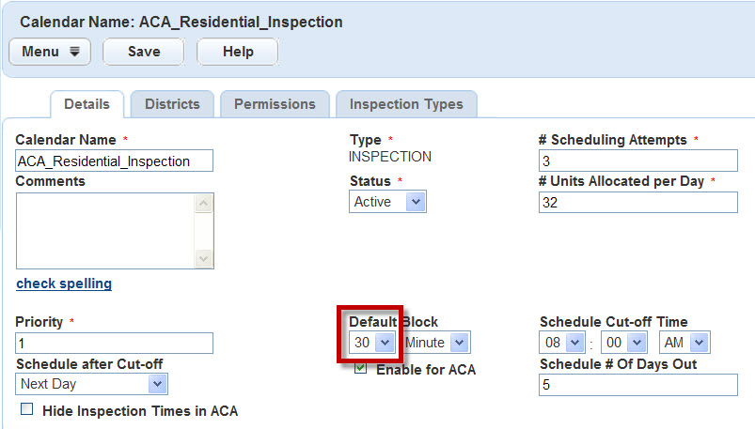

notes_final25For detailed instructions on how to configure these Standard Choices, see [Managing Standard Choices](http://community.accela.com/accela_automation/m/aatraining/8143/download.aspx) and the [Accela Automation 7.3 Configuration Reference](http://community.accela.com/accela_automation/m/accela_automation_-_documentation_73/7995/download.aspx).

## Setting the Inspection Types

For Accela Automation to successfully assign an inspector, an inspection date, and an inspection time, you need to set the inspection types for auto-assign inspections. To set an inspection type for auto-assignment:

1. Navigate to the Administration console page.

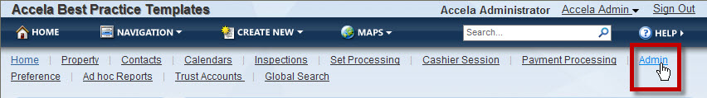

1. From the Quicklinks portlet, click AA Classic.

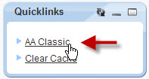

1. In the Application section of the AA Classic portlet, click Inspection.

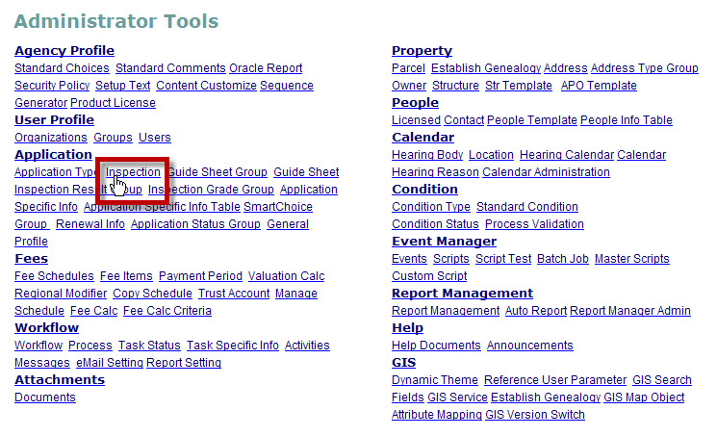

1. To search for the inspection group, type your query into the form, and then click Submit.

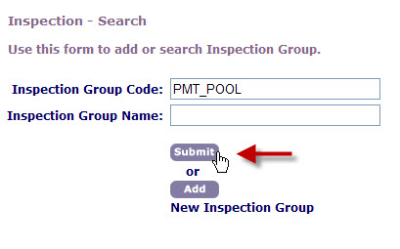

1. To open the inspection group, click the red dot.

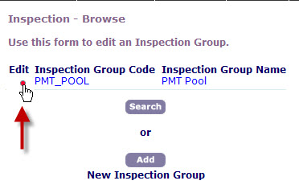

You see the inspection types in the inspection group:

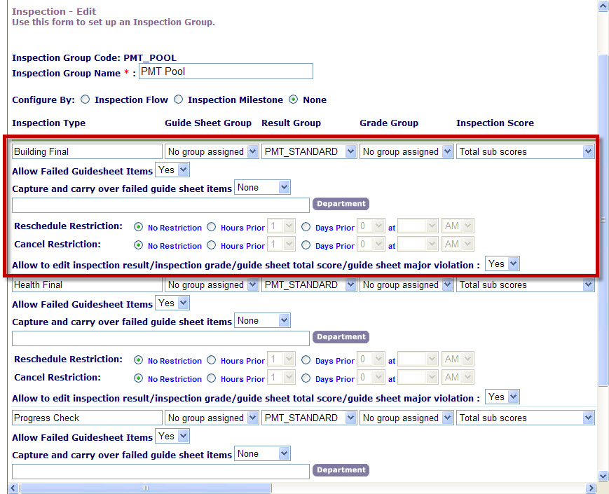

1. To set the inspection type so that users can auto-assign the inspectors, right-scroll to the Auto Assign field and choose Yes.

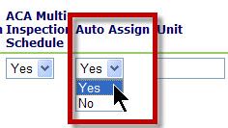

1. In the Unit field, type the number of inspection units.

notes_final25A unit represents a block of inspection time. For example, 1 unit might represent 30 minutes of inspection time.

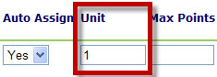

1. To save your changes, click Update at the bottom of the page.

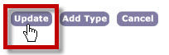

1. To set the inspection discipline:

notes_final25Before you can select an inspection discipline, you first need to add the disciplines to the shared drop-down list, USER\_DISCIPLINES. For instructions, see “Configuring Inspection Disciplines” on page 5.

1. Click Configuration located on the far-right of the inspection type.

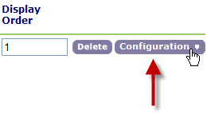

1. Click Inspection Disciplines.

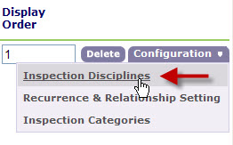

1. Click Add.

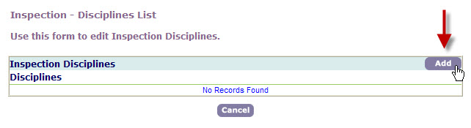

1. Mark the check boxes next to the relevant inspection disciplines, and then click Submit.

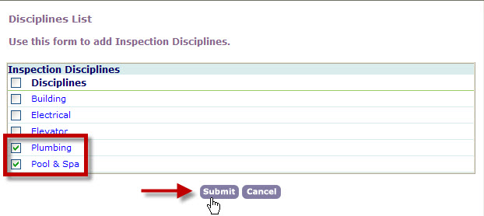

1. To return to the inspection group, click Cancel.

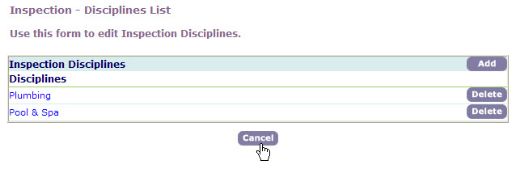

1. To save your changes, click Update at the bottom of the page.

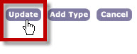

1. To close the inspection group, click Cancel at the bottom of the page.

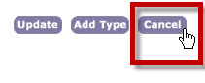

## Configuring the Inspection Calendar

For Accela Automation to successfully schedule auto-assign inspections, you need to configure one or more inspection calendars for your system.

notes_final25The procedures that follow focus solely on how to configure inspection calendars for auto-assignment. For information on the ACA settings and other possible options, see the [Accela Automation 7.3 Administrator Guide](http://community.accela.com/accela_automation/m/accela_automation_-_documentation_73/7992/download.aspx).

You can also combine inspection calendars with the User and Holiday calendars for scheduling auto-assign inspections. For more information on how to configure the User and Holiday calendars, see the [Accela Automation 7.3 Administrator Guide](http://community.accela.com/accela_automation/m/accela_automation_-_documentation_73/7992/download.aspx).

### To View an Inspection Calendar

1. Navigate to the Administration console page.

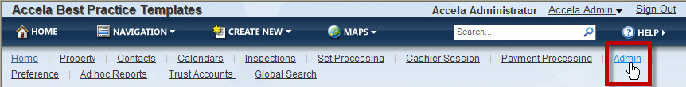

1. From the Setup portlet, choose Calendars > Calendar.

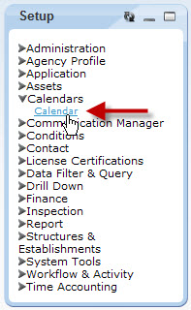

1. Expand Calendar by Type.

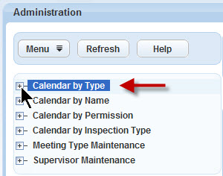

1. Expand Inspection.

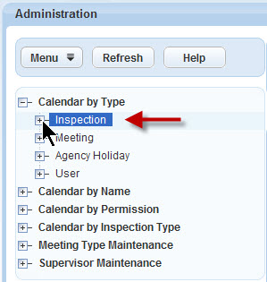

1. Click the calendar name.

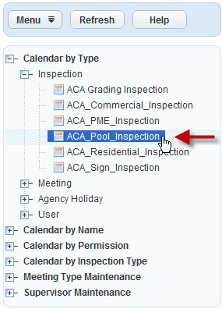

You see the calendar:

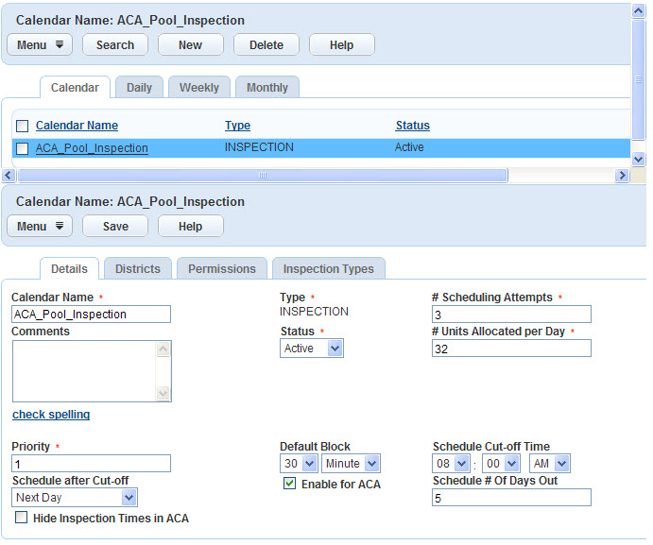

**To Add a New Inspection Calendar**

1. Navigate to the inspection calendars. For instructions, see Steps 1 through 4, starting on page 19.

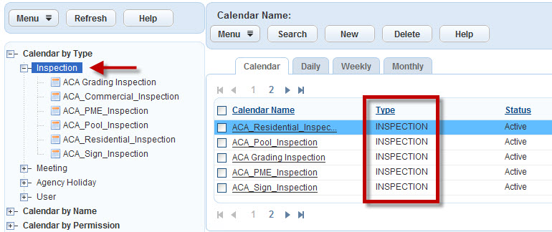

1. Click New.

Image of the mouse clicking the new button.

1. Fill in the form, and then click Submit.

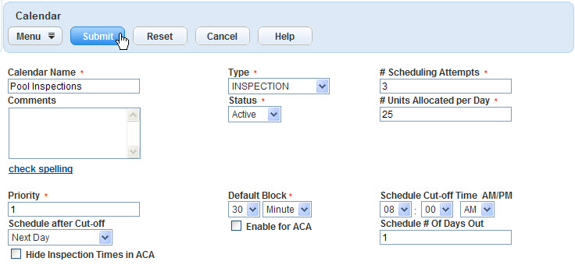

notes_final25**(1)** For detailed field definitions, see the [Accela Automation 7.3 Administrator Guide](http://community.accela.com/accela_automation/m/accela_automation_-_documentation_73/7992/download.aspx). **(2)** To successfully set the Default Block and the # Units Allocated per Day fields, you first need to configure the inspection time blocks. For instructions, see page 10. **(3)** The Priority field enables Accela Automation to prioritize multiple calendars when scheduling an inspection. The highest priority is 1.

You see a confirmation message:

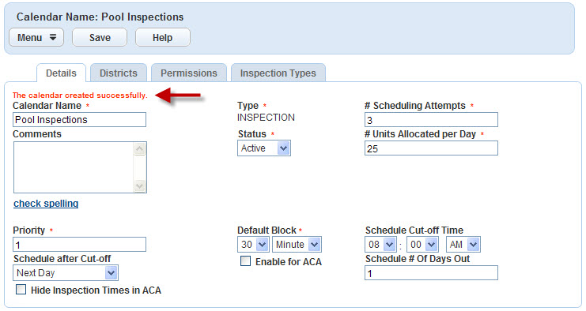

### To Schedule the Inspection Work Day

To specify the work hours for the inspectors, you can set the inspection times as well as the block-out times for meetings, breaks, and other non-inspection activities. To schedule the inspectors’ work day:

1. Open an inspection calendar. For instructions, see “To View an Inspection Calendar” on page 19.

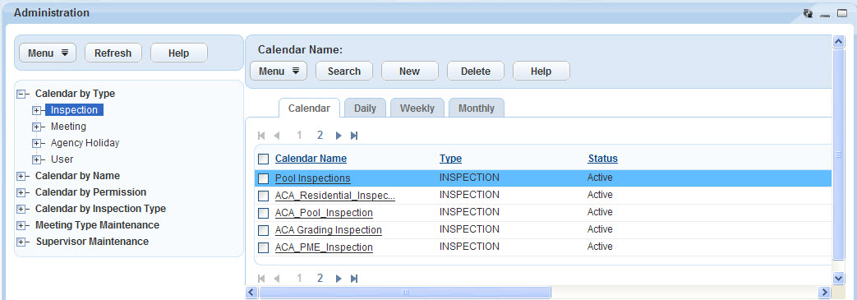

1. Click Daily.

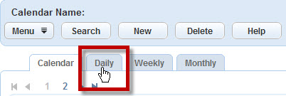

1. Click New.

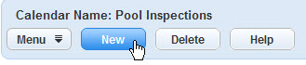

1. To set the inspection schedule:
2. From the Type menu, choose Inspection.

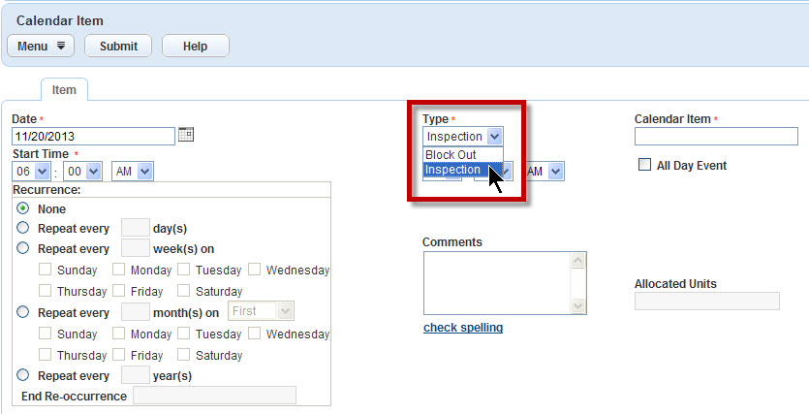

1. Fill in the rest of the form, and then click Submit.

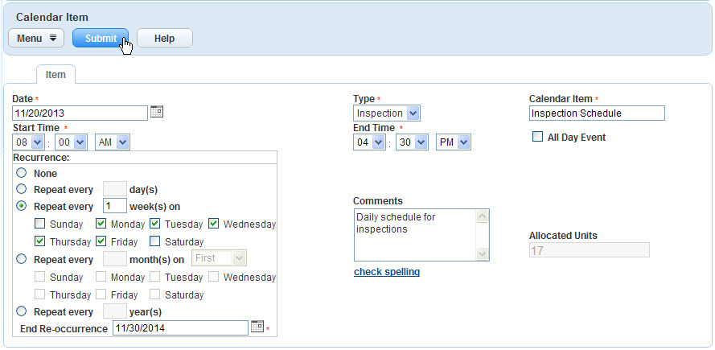

notes_final25For detailed field definitions, see the [Accela Automation 7.3 Administrator Guide](http://community.accela.com/accela_automation/m/accela_automation_-_documentation_73/7992/download.aspx).

You see the new calendar item:

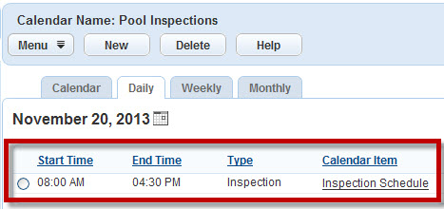

1. To block out a non-inspection time, such as a lunch break or meeting:
2. From the Type menu, choose Block Out.

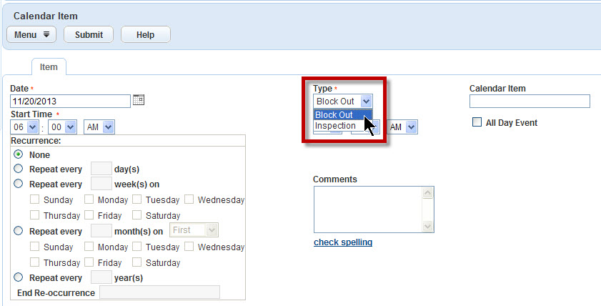

1. Fill in the rest of the form, and then click Submit.

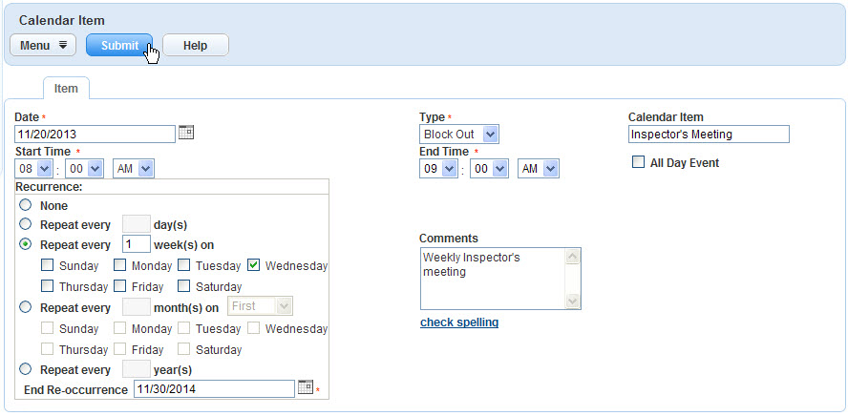

notes_final25For detailed field definitions, see the [Accela Automation 7.3 Administrator Guide](http://community.accela.com/accela_automation/m/accela_automation_-_documentation_73/7992/download.aspx).

You see the new block out time on the schedule:

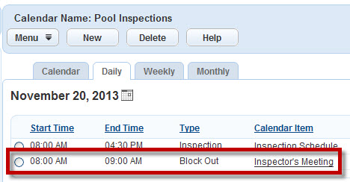

### To Restrict the Inspection Calendar to One or More inspection Districts

1. Open an inspection calendar. For instructions, see “To View an Inspection Calendar” on page 19.



1. From the detail portlet, click Districts.

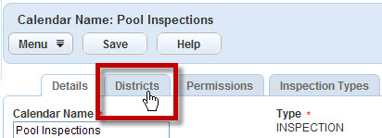

1. Click Assign.

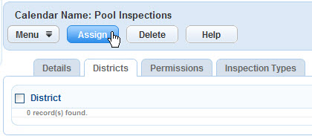

1. To restrict the calendar to one or more inspection districts, mark the appropriate check boxes.

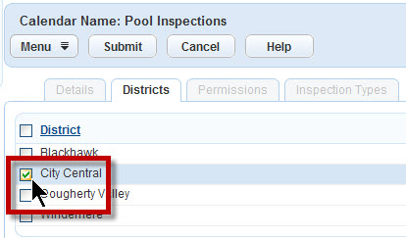

1. Click Submit.

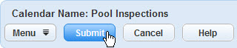

You see a confirmation message:

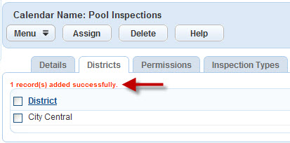

### To Restrict the Inspection Calendar to Specific Inspection Types

1. Open an inspection calendar. For instructions, see “To View an Inspection Calendar” on page 19.



1. From the detail portlet, click Inspection Types.

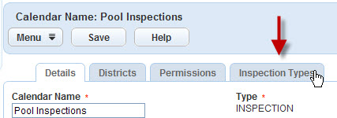

1. Click Assign.

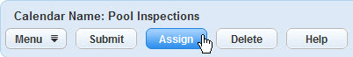

1. To select the inspection types for this calendar, mark the appropriate check boxes.

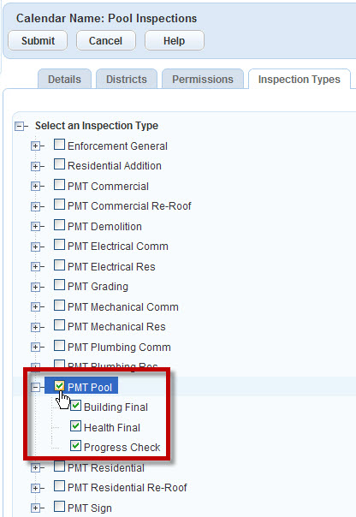

1. Click Submit.

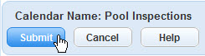

You see a confirmation message:

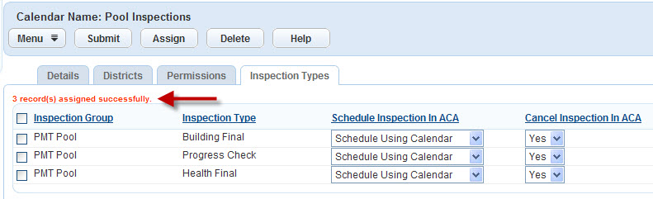

notes_final25For information on the ACA settings for the selected inspection types, see the [Accela Automation 7.3 Administrator Guide](http://community.accela.com/accela_automation/m/accela_automation_-_documentation_73/7992/download.aspx).

### **To Set User Access to the Inspection Calendar**

1. Open an inspection calendar. For instructions, see “To View an Inspection Calendar” on page 19.



1. From the detail portlet, click Permissions.

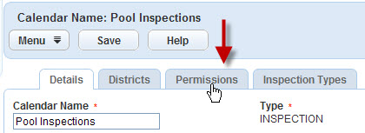

1. Click Assign.

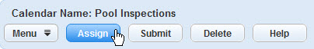

1. To select the modules, user groups, and users, mark the check boxes.

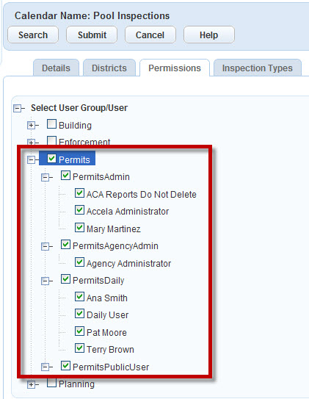

1. Click Submit.

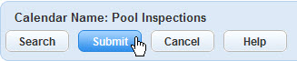

1. From the Access menu, choose the appropriate access level.

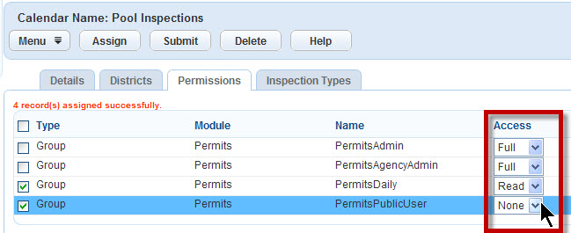

notes_final25By default, Accela Automation gives the selected groups and users **Full** access rights. If you want to restrict access to the inspection calendar, you need to change the access level.

1. Click Submit.

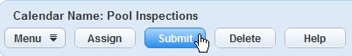

You see a confirmation message:

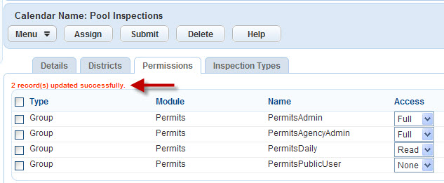

## Configuring Inspector Profiles

To configure an inspector profile:

1. Navigate to the Administration console page.



1. From the Quicklinks portlet, click AA Classic.



1. From the User Profile section of the AA Classic portlet, click Users.

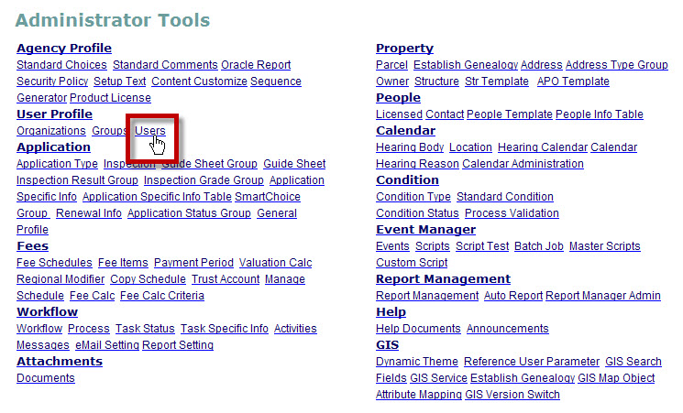

1. To find an inspector, type your search criteria into the form, and then click Submit.

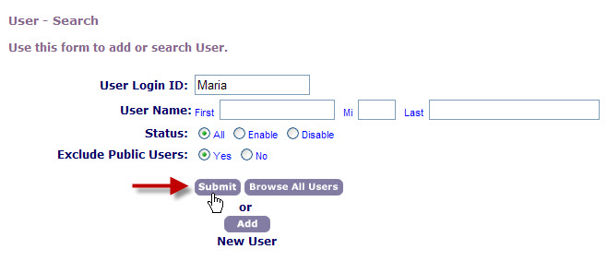

1. To open the inspector profile, click User Information.

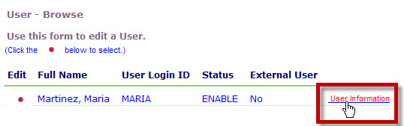

1. In the Daily Inspection Units field, type the maximum number of inspection units that this inspector can complete in one day. Then, click Submit.

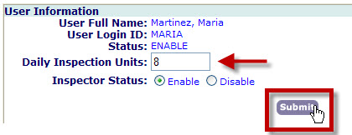

notes_final25For example, if 1 inspection unit = 30 minutes, then Accela Automation can schedule this inspector for a maximum of 4 hours of inspections each day.

1. In the Districts section, choose the GIS map service.

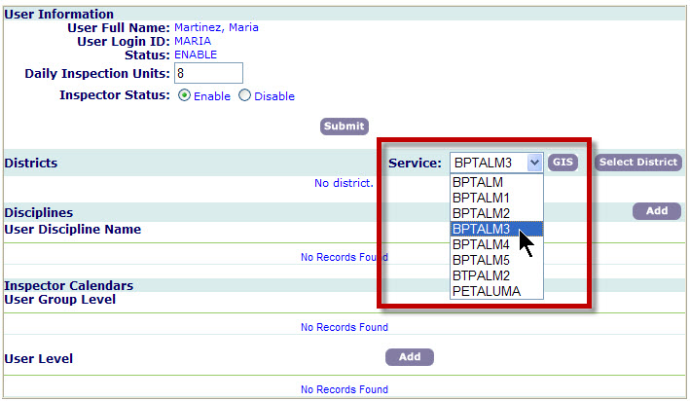

1. To set the inspection districts:
2. In the Districts section, click Select District.

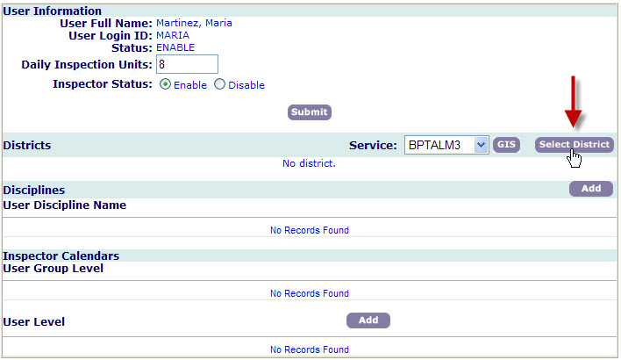

1. To select the districts, mark the check boxes, and then click Submit.

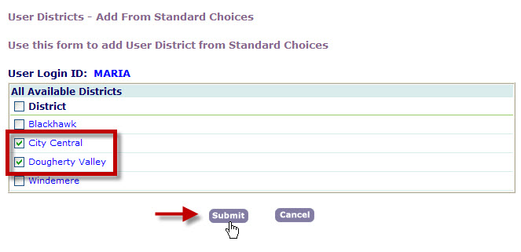

1. To set the inspection disciplines:
2. In the Disciplines section, click Add.

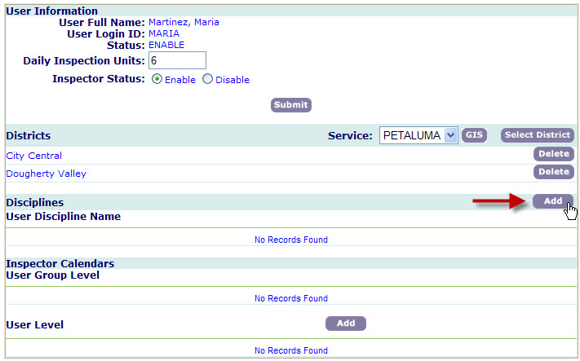

1. To select the disciplines, mark the check boxes, and then click Submit.

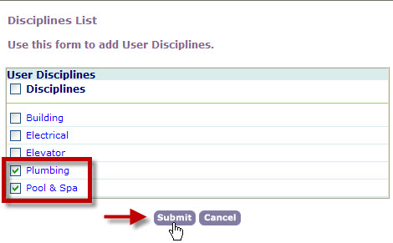

1. When you are finished, close the inspector profile.

notes_final25The Inspector Calendars section is solely for Accela Automation Classic. When configuring auto-assign inspections, this section should remain empty.

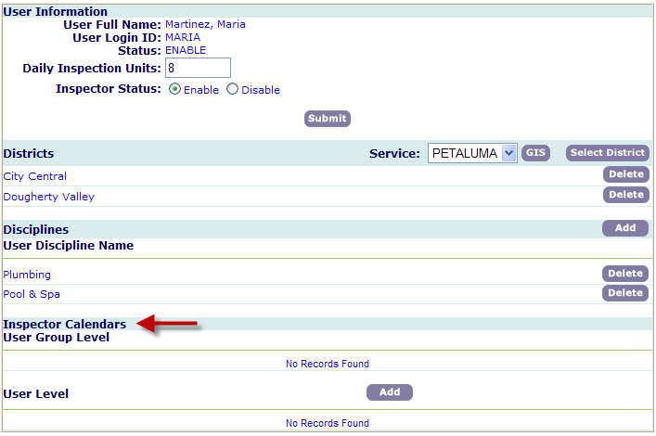

ExcerciseLine1.bmp

## Exercises and Questions

To reinforce what you have learned, answer the questions and complete the exercises that follow:

* What are auto-assign inspections? How do they benefit end-users?
* Enable all of the FIDs for auto-assign inspections.
* Configure the inspection disciplines.
* Configure the inspection districts, and then associate them with several reference addresses or parcels.
* Configure the inspection time blocks. What are they? How are they used throughout Accela Automation?
* Set several inspection types for auto-assignment.
* Configure an inspection calendar and associate it with the inspection types you set to auto-assign.
* Configure an inspector profile.
* Verify all of your auto-assignment settings to make sure they are all in agreement.
* Schedule an auto-assign inspection. If you have any errors, resolve them.
* Extra Credit: Configure either a user or a holiday calendar, and then schedule another auto-assign inspection. Does the inspection include the new calendar settings?

ExcerciseLine2.bmp

## Related Information

You can find the following related information on the Accela Community Web site:

* [Configuring Inspections](http://community.accela.com/accela_automation/m/aatraining/8120/download.aspx) (Course Guide)
* [Setting Function Identifiers](http://community.accela.com/accela_automation/m/aatraining/8135/download.aspx) (Course Guide)
* [Managing Standard Choices](http://community.accela.com/accela_automation/m/aatraining/8143/download.aspx) (Course Guide)
* [Configuring Shared Drop-Down Lists](http://community.accela.com/accela_automation/m/aatraining/8144/download.aspx) (Course Guide)
* [Accela Automation 7.3 Administrator Guide](http://community.accela.com/accela_automation/m/accela_automation_-_documentation_73/7992/download.aspx) (Manual)
* [Accela Automation 7.3 Configuration Reference](http://community.accela.com/accela_automation/m/accela_automation_-_documentation_73/7995/download.aspx) (Manual)